Today you will understand

Now you will understand subtraction

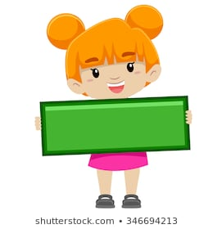

 can you count the cats?

Now take away one

